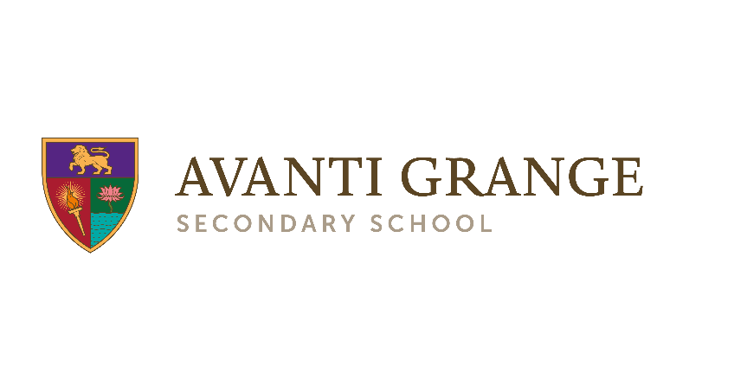
Super Curriculum: History
Year 9

The Super Curriculum complements the Avanti Grange taught curriculum. Super Curriculum activities take topics of study in the classroom further, allowing students to explore areas of interest in greater depth, and point students to additional topics of interest beyond the taught curriculum.
Super Curriculum activities can take a wide variety of forms. Students are free to choose the activity that most interests them. Participating in Super Curriculum activities will help students to broaden their horizons, nurture their love of learning, open their eyes to the world through different disciplines, and build their wider knowledge and cultural capital.
 | Watch |  | Research |  | Watch/research
BBC documentary: Empire of the Tsars  Historian Lucy Worsley presents a series of documentaries about the Romanov dynasty, the family that ruled Russia from 1613 until the Russian Revolution in 1917. You can watch the series on BBC iPlayer by following the link below.  Resources/link: Empire of the Tsars: Romanov Russia with Lucy Worsley - BBC iPlayer |  | Family or local links to the First World War  Use the Commonwealth War Graves Commission website, the National Archives, Imperial War Museum or A Street Near You to research family or local links to the First World War. Present what you find out as a presentation, poster, written account, video or podcast.  Resources/link:  Commonwealth War Graves Commission  A street near you  National Archives First World War records  IWM – Lives of the First World War |  | BBC - WW1 Uncut  Learn more about the First World War, including fighting in the trenches, the weapons used, and the experience of war in other parts of the world, from this series of short documentary clips with historians Dan Snow and David Olusoga.  Make a poster, presentation or podcast about what you find out.  Resources/link:  WW1 Uncut with Dan Snow and David Olusoga (YouTube playlist)
 | Read |  | Visit |  | Listen
Holocaust/Shoah memoirs or historical fiction  Read The Diary of a Young Girl by Anne Frank or When Hitler Stole Pink Rabbit by Judith Kerr or the graphic novel Maus by Art Spiegelmann. Alternatively, choose another Holocaust memoir or historical fiction from the list below.  Also read this article about the problems with the portrayal of the Holocaust in the popular novel The Boy in the Striped Pyjamas.  Resources/link:  Holocaust books for young adults |  | Visit the Imperial War Museum, London  Visit the Imperial War Museum, London, to see the First and Second World War galleries, and other galleries relating to the Second World War. The Holocaust Galleries are for ages 14 and over, and the content is distressing so if you visit, you should do so with an adult.  Have lunch with a history teacher after your visit and discuss what you saw.  Resources/link:  Imperial War Museum, London (free entry) |  | Listen to the Empire podcast  Choose one or more episodes of the Empire podcast with William Dalrymple and Anita Anand. This could be about any topic, but to link to the Year 9 curriculum you might want to choose:  - Episodes 90 and 91 about the Russian Revolution and Lenin  - Episodes 46 and 47 about rebellion against the British empire in the 20th century  - Episodes 38-40 about the Middle East  - Episodes 1-20 – the whole history of Britain and India from East India Company to the end of empire  - Episodes 170, 171 and 201 about the British Empire, India and the Second World War  Resources/link:  Empire podcast

