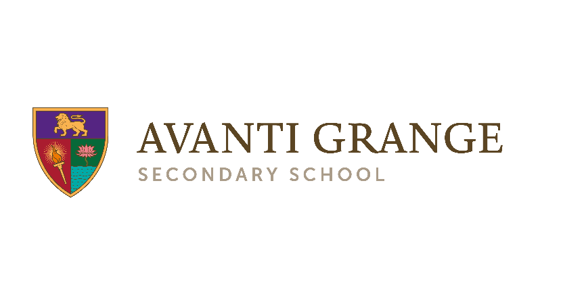
Super Curriculum: Physical Education
Year 9

The Super Curriculum complements the taught curriculum at Avanti Grange. Super Curriculum activities take topics of study in the classroom further, allowing students to explore areas of interest in greater depth, and point students to additional topics beyond the taught curriculum.
Super Curriculum activities can take a wide variety of forms. Students are free to choose the activity that most interests them. Participating in Super Curriculum activities will help students to broaden their horizons, nurture their love of learning, open their eyes to the world through different disciplines, and build their wider knowledge and cultural capital.
 | Watch |  | Read |  | Listen
Attend a league or cup match of a professional or semi-professional game in any sport.  Write a summary of the game as if you are a sports journalist.  Resources/link: |  | Read a sporting biography of someone you admire.  Write a book report to review what you have read.  Resources/link: |  | Choose an episode of the High-Performance Podcast to listen too.  Make a mind-map about what you have learned.  Resources/link: High-Performance Podcast
 | Research |  | Visit |  | Visit
Research a sportsperson you want to emulate.  Produce a timeline of their life, including career highlights.  Resources/link: |  | Go on a stadium tour anywhere in the world or visit a sports museum.  Write five interesting facts you learnt.  Resources/link: |  | Visit and compete in a local Parkrun or similar fitness event.  Resources/link: Parkrun Events

Icons:
 | Read |  | Research |  | Watch |  | Listen
 | Create |  | Write |  | Plan/design |  | Visit

