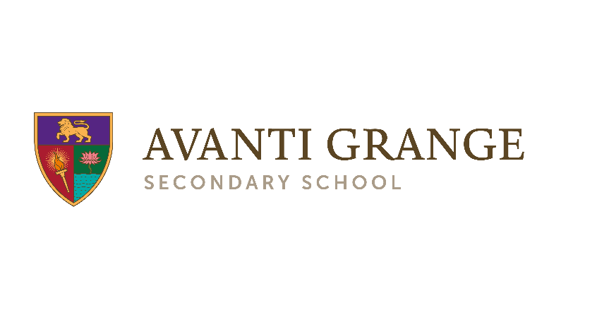
Super Curriculum:

The Super Curriculum complements the Avanti Grange taught curriculum. Super Curriculum activities take topics of study in the classroom further, allowing students to explore areas of interest in greater depth, and point students to additional topics of interest beyond the taught curriculum.
Super Curriculum activities can take a wide variety of forms. Students are free to choose the activity that most interests them. Participating in Super Curriculum activities will help students to broaden their horizons, nurture their love of learning, open their eyes to the world through different disciplines, and build their wider knowledge and cultural capital.
 | Read |  | Visit |  | Visit (Online)
Alex’s Adventures in Numberland, by Alex Bellos - an exhilarating cocktail of history, reportage and mathematical proofs that will leave you awestruck.  The Colossal Book of Short Puzzles and Problems, by Martin Gardner - collection of short and inventive problems by popular mathematics and science writer  Resources/link: |  | Science Museum – Maths Gallery - visit newly open section of Science Museum involving various aspects of Maths  Bletchley Park – visit Blechley Park and explore the world of coding and maths  Resources/link:  https://www.bletchleypark.org.uk/visit-us |  | King’s College London – visit KCL site and attempt one of the weekly challenge competitions –  https://www.kcl.ac.uk/mathsschool/Weekly-Maths-Challenge/Weeklymaths-challenge.aspx  Wild Maths – explore, imagine, experiment, create! – try and explore one of the games from the nrich site: http://wild.maths.org/  Resources/link:
 | Plan/design |  | Watch |  | Listen
Design a house or a school, producing full scale drawing, calculating area and showing all the relevant measurements. Complete the task by creating Paper or cardboard model. |  | Watch Movie based on mathematician Alan Turing’s involvement in code breaking of Enigma – ‘The Imagination Game’ directed by Morten Tyldum  Beautiful Equations (2010) – BBC documentary featuring Stephen Hawkins and Matthew Collins (maths and art together)  https://www.youtube.com/watch?v=059xIxwb3tM  BBC Universe Documentary The Great Math Mystery BBC Documentary 2015 –  https://www.youtube.com/watch?v=JiH7lMGW60A  Documentary : Top 10 equations that changed the world  https://www.youtube.com/watch?v=0K-t090uvL4 |  | Listen to Travels in a Mathematical World podcast, by Peter Rowlett – featuring mathematicians talking about their work as well as features on maths history and maths news  http://www.travelsinamathematicalworld.co.uk/  Listen to maths documentary podcast – Relatively Prime, by Samuel Hansen –  http://relprime.com/

 | Read |  | Research |  | Watch |  | Listen
 | Create |  | Write |  | Plan/design |  | Visit

